**Pract 1:- Mathematical Tools for Image Processing**

**Create PYTHON CODE to transform an image in special domain into its frequency domain using DFT**

import numpy as np

import matplotlib.pyplot as plt

image_filename = r"D:\2023 Birla MSc-Bsc\MSc\MSc IT - IP\Practs\mobile.webp"

def calculate_2dft(input):

ft = np.fft.ifftshift(input)

ft = np.fft.fft2(ft)

return np.fft.fftshift(ft)

# Read and process image

image = plt.imread(image_filename)

image = image[:, :, :3].mean(axis=2) # Convert to grayscale

plt.set_cmap("gray")

ft = calculate_2dft(image)

plt.subplot(121)

plt.imshow(image)

plt.axis("off")

plt.subplot(122)

plt.imshow(np.log(abs(ft)))

plt.axis("off")

plt.show()

vertical and horizontal lines in image

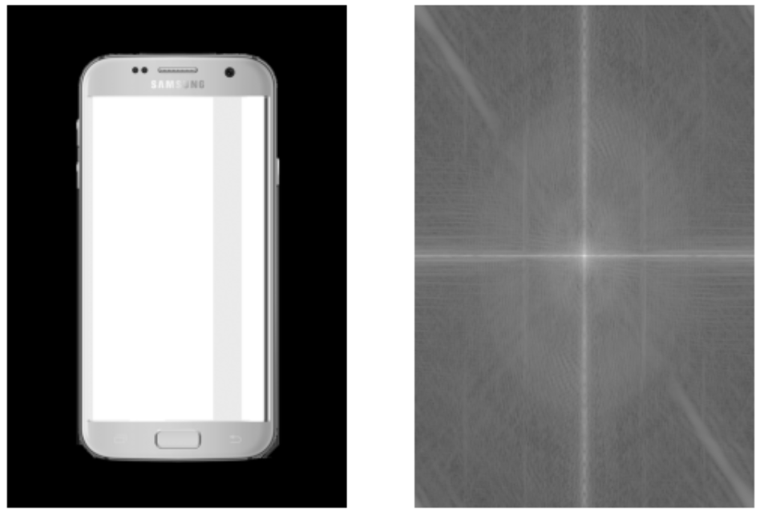

Vertical lines

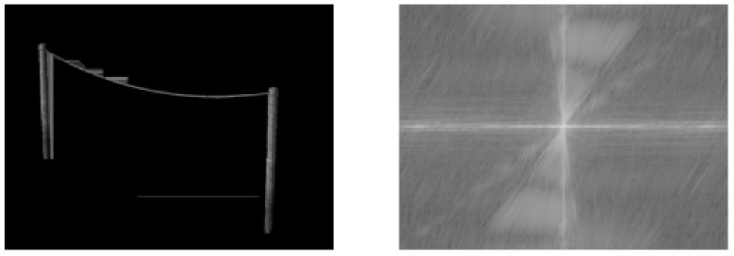

Horizontal lines

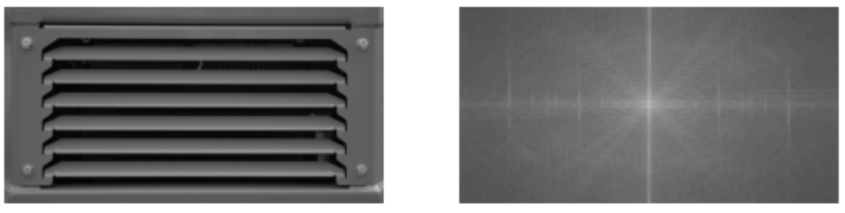

Diagonal lines

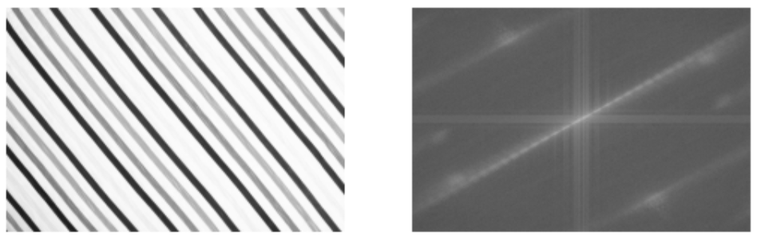

**Pract 2:- Image Enhancement in Spatial Domain**

**Create a python code to demonstrate the spatial domain image enhancement methods like: Image Contrast Stretching, Log Transform, Power Law Transform, Image Averaging and Median Filter**

**Contrast Stretching**

import cv2

import numpy as np

import matplotlib.pyplot as plt

# Load the image in grayscale

img = cv2.imread(r"D:\2023 Birla MSc-Bsc\MSc\MSc IT - IP\Practs\low_contrast.jpg")

# Get min and max intensity values

min_val = np.min(img)

max_val = np.max(img)

# Apply contrast stretching formula

stretched = ((img - min_val) / (max_val - min_val) * 255).astype(np.uint8)

# Display original and stretched image side by side

plt.figure(figsize=(10, 5))

plt.subplot(1, 2, 1)

plt.title("Original Image")

plt.imshow(img)

plt.axis('off')

plt.subplot(1, 2, 2)

plt.title("Contrast Stretched")

plt.imshow(stretched, cmap='gray')

plt.axis('off')

plt.show()

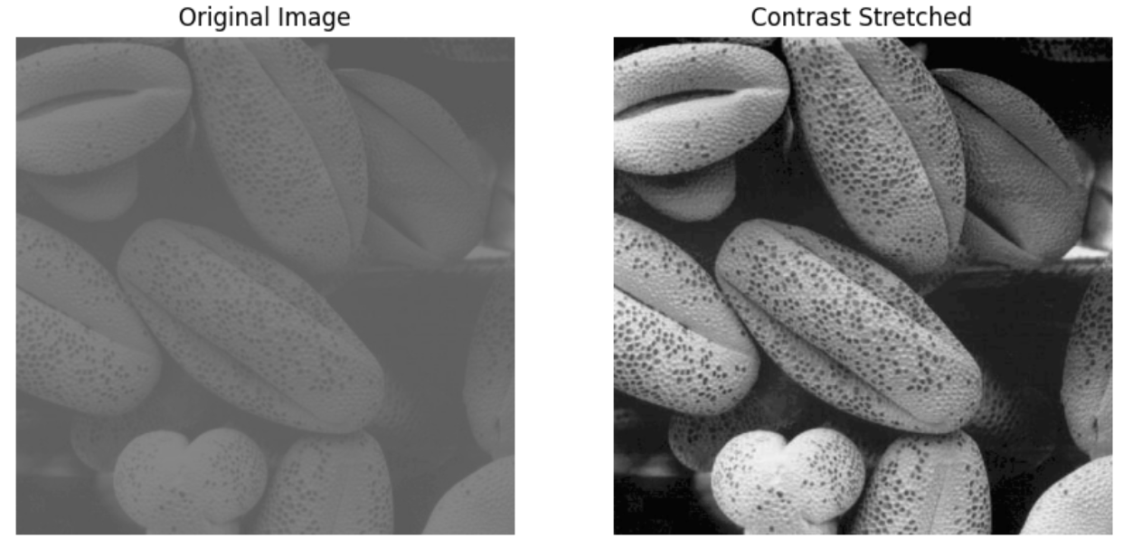

**Log Transform**

# import Pillow modules

from PIL import Image

from PIL import ImageFilter

import math

# Compute log

def logTransform(c, f):

g = c * math.log(float(1 + f),10);

return g;

# Apply logarithmic transformation for an image

def logTransformImage(image, outputMax = 255, inputMax=255):

c = outputMax/math.log(inputMax+1,10);

print(c)

# Read pixels and apply logarithmic transformation

for i in range(0, img.size[0]-1):

for j in range(0, img.size[1]-1):

# Get pixel value at (x,y) position of the image

f = img.getpixel((i,j));

# Do log transformation of the pixel

redPixel = round(logTransform(c, f[0]));

greenPixel = round(logTransform(c, f[1]));

bluePixel = round(logTransform(c, f[2]));

# Modify the image with the transformed pixel values

img.putpixel((i,j),(redPixel, greenPixel, bluePixel));

return image;

# Display the original image

imageFileName = r"D:\2023 Birla MSc-Bsc\MSc\MSc IT - IP\Practs\jungle.jpg";

img = Image.open(imageFileName);

#img.show();

plt.subplot(121),plt.imshow(img),plt.title('Original')

plt.xticks([]), plt.yticks([])

# Display the image after applying the logarithmic transformation

logTransformedImage = logTransformImage(img);

#logTransformedImage.show();

plt.subplot(122),plt.imshow(logTransformedImage),plt.title('logTransformedImage')

plt.xticks([]), plt.yticks([])

plt.show()

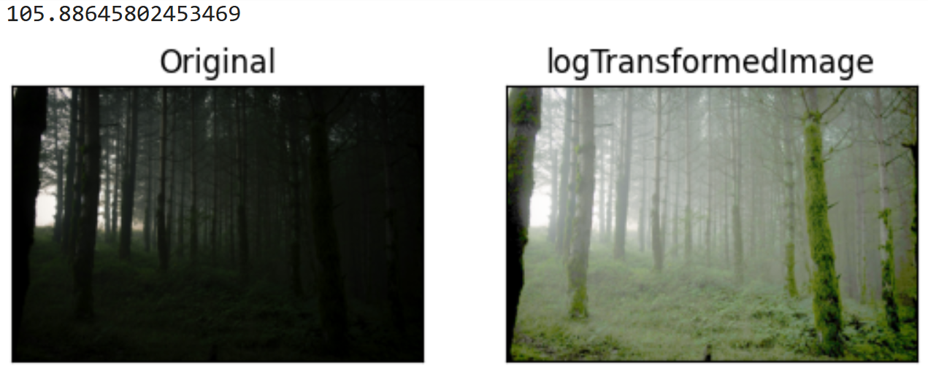

**Power Law Transform**

import cv2

import matplotlib.pyplot as plt

import math

import numpy as np

#this type of processing is suited for displaying image correctly for human eye based on monitor's display settings

# Read an image

image = cv2.imread(r"D:\2023 Birla MSc-Bsc\MSc\MSc IT - IP\Practs\jungle.jpg")

plt.imshow(image)

plt.show()

# Trying 7 gamma values.

for gamma in [0.1, 0.3, 0.4, 0.5, 1.2, 2.2, 3.2]:

# Apply gamma correction.

gamma_corrected = np.array(255*(image / 255) ** gamma, dtype = 'uint8')

plt.imshow(gamma_corrected)

plt.show()

**Image Averaging**

import numpy as np

import cv2 as cv

from matplotlib import pyplot as plt

img = cv.imread(r"D:\2023 Birla MSc-Bsc\MSc\MSc IT - IP\Practs\averaging.jpg")

assert img is not None, "file could not be read, check with os.path.exists()"

kernel = np.ones((5,5),np.float32)/25

dst = cv.filter2D(img,-1,kernel)

plt.subplot(121),plt.imshow(img),plt.title('Original')

plt.xticks([]), plt.yticks([])

plt.subplot(122),plt.imshow(dst),plt.title('Averaging')

plt.xticks([]), plt.yticks([])

plt.show()

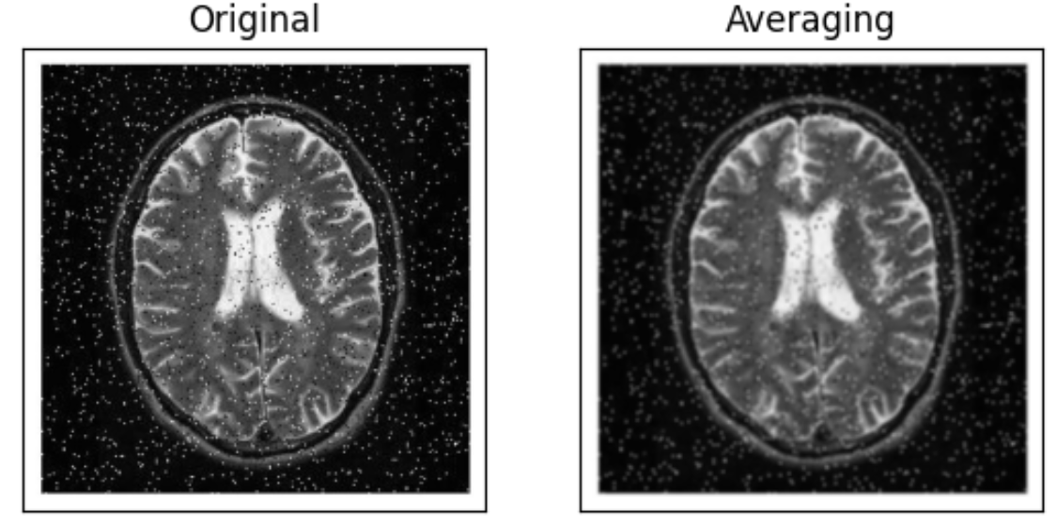

**Median Filter**

from PIL import Image, ImageFilter

from matplotlib import pyplot as plt

im = Image.open(r"D:\2023 Birla MSc-Bsc\MSc\MSc IT - IP\Practs\averaging.jpg")

im1 = im.filter(ImageFilter.MedianFilter(size = 7))

plt.subplot(121),plt.imshow(im),plt.title('Original')

plt.xticks([]), plt.yticks([])

plt.subplot(122),plt.imshow(im1),plt.title('Median')

plt.xticks([]), plt.yticks([])

plt.show()

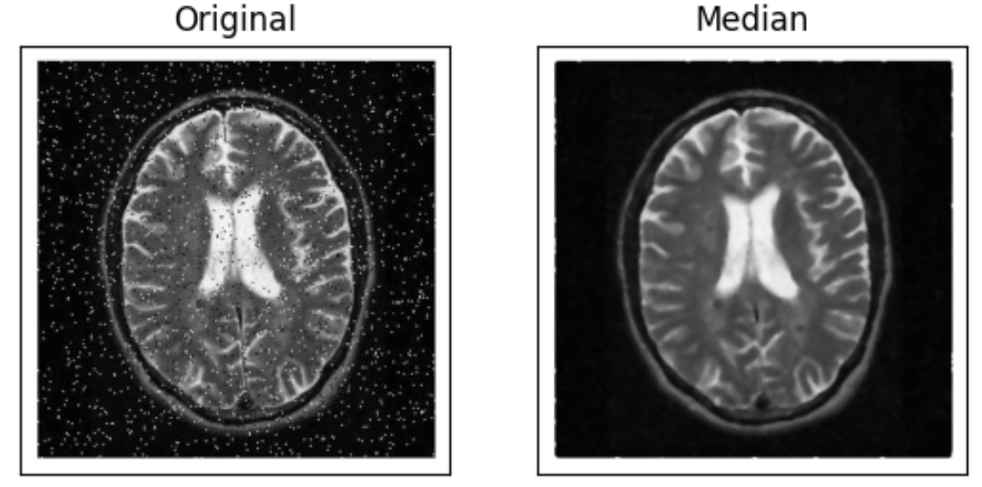

**Pract3:- Image Enhancement in Frequency Domain**

**Create a python code to demonstrate the frequency domain image enhancement methods like: Ideal, Gaussian, Butterworth Low Pass & Ideal, Gaussian, Butterworth High Pass Filter.**

**Ideal Low and High Pass Filter**

import cv2

import numpy as np

import matplotlib.pyplot as plt

# original image

f = cv2.imread(r"D:\2023 Birla MSc-Bsc\MSc\MSc IT - IP\Practs\averaging.jpg",0)

plt.imshow(f, cmap='gray')

plt.axis('off')

plt.show()

# image in frequency domain

F = np.fft.fft2(f)

Fshift = np.fft.fftshift(F)

plt.imshow(np.log1p(np.abs(Fshift)),

cmap='gray')

plt.axis('off')

plt.show()

# Filter: Low pass filter

M,N = f.shape

H = np.zeros((M,N), dtype=np.float32)

D0 = 25

for u in range(M):

for v in range(N):

D = np.sqrt((u-M/2)**2 + (v-N/2)**2)

if D <= D0:

H[u,v] = 1

else:

H[u,v] = 0

plt.imshow(H, cmap='gray')

plt.axis('off')

plt.show()

# Ideal Low Pass Filtering

Gshift = Fshift * H

# Inverse Fourier Transform

G = np.fft.ifftshift(Gshift)

g = np.abs(np.fft.ifft2(G))

plt.imshow(g, cmap='gray')

plt.axis('off')

plt.show()

# Filter: High pass filter

H = 1 - H

plt.imshow(H, cmap='gray')

plt.axis('off')

plt.show()

# Ideal High Pass Filtering

Gshift = Fshift * H

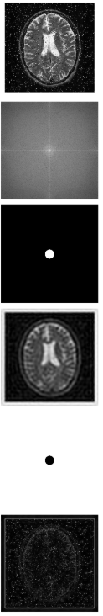

# Inverse Fourier Transform

G = np.fft.ifftshift(Gshift)

g = np.abs(np.fft.ifft2(G))

plt.imshow(g, cmap='gray')

plt.axis('off')

plt.show()

**Butterworth Low and High Pass Filter**

import cv2

import numpy as np

import matplotlib.pyplot as plt

# open the image

f = cv2.imread(r"D:\2023 Birla MSc-Bsc\MSc\MSc IT - IP\Practs\averaging.jpg",0)

# transform image into freq. domain and shifted

F = np.fft.fft2(f)

Fshift = np.fft.fftshift(F)

plt.imshow(np.log1p(np.abs(Fshift)), cmap='gray')

plt.axis('off')

plt.show()

# Butterwort Low Pass Filter

M,N = f.shape

H = np.zeros((M,N), dtype=np.float32)

D0 = 10 # cut of frequency

n = 10 # order

for u in range(M):

for v in range(N):

D = np.sqrt((u-M/2)**2 + (v-N/2)**2)

H[u,v] = 1 / (1 + (D/D0)**n)

plt.imshow(H, cmap='gray')

plt.axis('off')

plt.show()

# frequency domain image filters

Gshift = Fshift * H

G = np.fft.ifftshift(Gshift)

g = np.abs(np.fft.ifft2(G))

plt.imshow(g, cmap='gray') plt.axis('off')

plt.show()

# Butterworth High Pass Filter

HPF = np.zeros((M,N), dtype=np.float32)

D0 = 10

n = 1

for u in range(M):

for v in range(N):

D = np.sqrt((u-M/2)**2 + (v-N/2)**2)

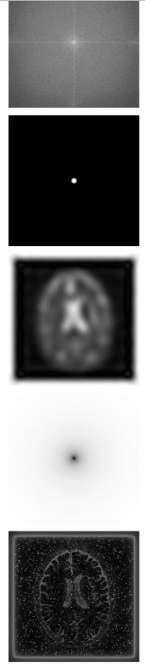 HPF[u,v] = 1 / (1 + (D0/D)**n)

plt.imshow(HPF, cmap='gray') plt.axis('off')

plt.show()

# frequency domain image filters

Gshift = Fshift * HPF

G = np.fft.ifftshift(Gshift)

g = np.abs(np.fft.ifft2(G))

plt.imshow(g, cmap='gray') plt.axis('off')

plt.show()

**Gaussian Low and High Pass Filter**

import cv2

import numpy as np

import matplotlib.pyplot as plt

# open the image f

f = cv2.imread(r"D:\2023 Birla MSc-Bsc\MSc\MSc IT - IP\Practs\averaging.jpg",0)

plt.figure(figsize=(5,5))

plt.imshow(f, cmap='gray')

plt.axis('off')

plt.show()

# transform the image into frequency domain, f --> F

F = np.fft.fft2(f)

Fshift = np.fft.fftshift(F)

plt.figure(figsize=(5,5))

plt.imshow(np.log1p(np.abs(Fshift)), cmap='gray')

plt.axis('off')

plt.show()

# Create Gaussin Filter: Low Pass Filter

M,N = f.shape

H = np.zeros((M,N), dtype=np.float32)

D0 = 10

for u in range(M):

for v in range(N):

D = np.sqrt((u-M/2)**2 + (v-N/2)**2)

H[u,v] = np.exp(-D**2/(2*D0*D0))

plt.figure(figsize=(5,5))

plt.imshow(H, cmap='gray')

plt.axis('off')

plt.show()

# Image Filters

Gshift = Fshift * H

G = np.fft.ifftshift(Gshift)

g = np.abs(np.fft.ifft2(G))

plt.figure(figsize=(5,5))

plt.imshow(g, cmap='gray')

plt.axis('off')

plt.show()

# Gaussian: High pass filter

HPF = 1 - H

plt.figure(figsize=(5,5))

plt.imshow(HPF, cmap='gray')

plt.axis('off')

plt.show()

# Image Filters

Gshift = Fshift * HPF

G = np.fft.ifftshift(Gshift)

g = np.abs(np.fft.ifft2(G))

plt.figure(figsize=(5,5))

plt.imshow(g, cmap='gray')

plt.axis('off')

plt.show()

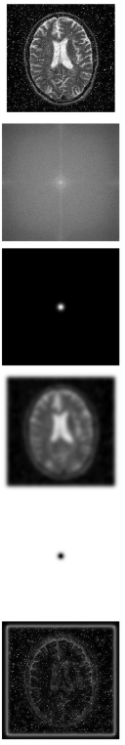

**Pract4:- Illustration of Segmentation techniques.**

**Create a python code to demonstrate image segmentation using varying techniques like Global Thresholding and Region Growing.**

**Image Segmentation using Global Thresholding**

import numpy as np

import matplotlib.pyplot as plt

from skimage.io import imread, imshow

from skimage.color import rgb2gray

import cv2

plt.figure(figsize=(6,6))

chico = imread(r"D:\2023 Birla MSc-Bsc\MSc\MSc IT - IP\Practs\chico.jpg")

plt.imshow(chico);

th_values = np.linspace(0, 1, 11)

fig, axis = plt.subplots(2, 5, figsize=(15,8))

chico_gray = rgb2gray(chico)

for th, ax in zip(th_values, axis.flatten()):

chico_binarized = chico_gray < th

ax.imshow(chico_binarized)

ax.set_title('$Threshold = %.2f$' % th)

ax.axis("off")

plt.tight_layout()

plt.show()

# Ask user to select a threshold

user_input = input("Enter the threshold value you liked (e.g., 0.3): ")

try:

final_th = float(user_input)

except ValueError:

print("Invalid input. Using default threshold 0.5.")

final_th = 0.5

# Apply final threshold and save/show

final_binarized = chico_gray < final_th

# Show the final image

plt.figure()

plt.imshow(final_binarized, cmap='gray')

plt.title(f'Final Thresholded Image @ {final_th:.2f}')

plt.axis('off')

plt.show()

# Save the final result

cv2.imwrite(r"D:\2023 Birla MSc-Bsc\MSc\MSc IT - IP\Practs\chico_final_binarized.png", (final_binarized * 255).astype('uint8'))

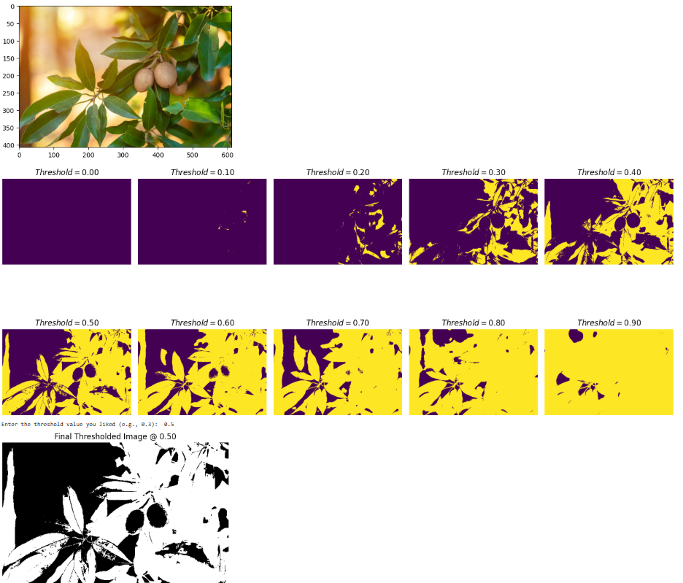

**Image Segmentation using Region Growing algorithm**

import numpy as np

import matplotlib.pyplot as plt

from scipy.ndimage import binary_dilation

# Original image (imaginary region to be filled)

A = np.array([

[0, 0, 0, 0, 0, 0, 0],

[0, 0, 1, 1, 0, 0, 0],

[0, 1, 0, 0, 1, 0, 0],

[0, 1, 0, 0, 1, 0, 0],

[0, 0, 1, 0, 1, 0, 0],

[0, 1, 0, 0, 1, 0, 0],

[0, 0, 1, 0, 0, 1, 0],

[0, 1, 0, 0, 0, 1, 0],

[0, 1, 1, 1, 1, 0, 0],

[0, 0, 0, 0, 0, 0, 0]

])

# Complement of original image

Ac = 1 - A

# Structuring element

B = np.array([

[0, 1, 0],

[1, 1, 1],

[0, 1, 0]

])

# Seed point to start filling

x = np.zeros_like(A)

x[2, 2] = 1

# Visualization setup

fig, axs = plt.subplots(1, 3, figsize=(12, 4))

plt.gray()

# Show original image

axs[0].imshow(A)

axs[0].set_title("Original A")

# Region filling loop

k = 0

flag_region_found = False

while not flag_region_found:

k += 1

axs[1].imshow(x)

axs[1].set_title(f"Filling iteration {k}")

plt.pause(0.6)

xnew = np.logical_and(binary_dilation(x, B), Ac)

diff = xnew.astype(int) - x.astype(int)

if np.sum(diff) == 0:

flag_region_found = True

else:

x = xnew

# Combine filled region with original

y = np.logical_or(x, A)

axs[2].imshow(y)

axs[2].set_title("Final Filled Region")

plt.tight_layout()

plt.show()

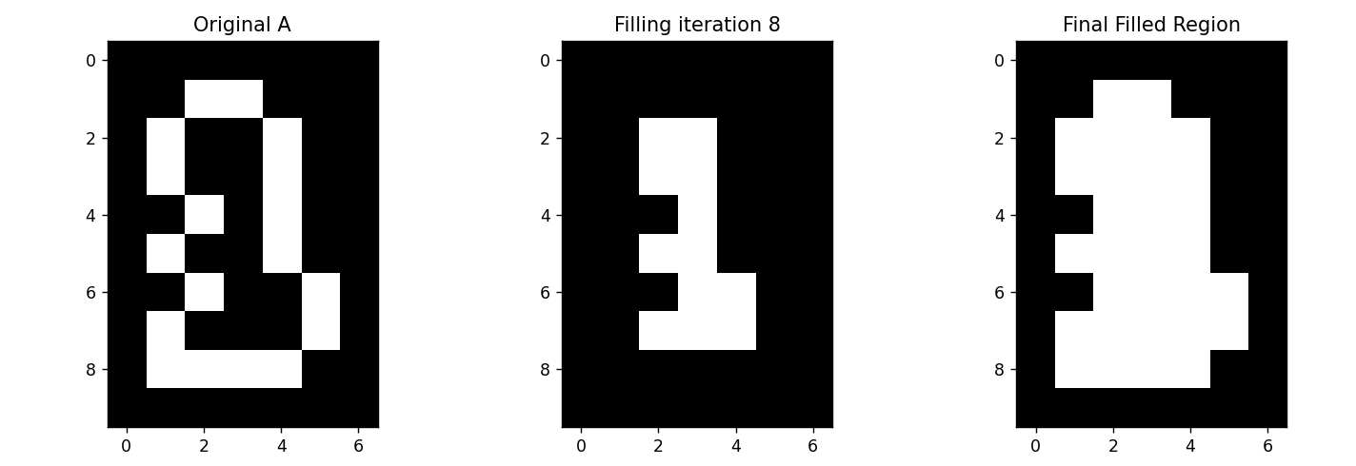

**Pract5:- Image Compression Technique**

**Create python code for demonstrating Image Compression using Run Length Coding algorithm.**

import numpy as np

import cv2 # or use imageio if you prefer

def rle_encode(arr):

# Encode 1D numpy array using Run-Length Encoding.

# Returns list of (value, count) pairs.

if len(arr) == 0:

return []

encoded = []

prev_value = arr[0]

count = 1

for val in arr[1:]:

if val == prev_value:

count += 1

else:

encoded.append((prev_value, count))

prev_value = val

count = 1

encoded.append((prev_value, count))

return encoded

def rle_decode(encoded):

# Decode RLE-encoded data back to 1D numpy array.

decoded = []

for value, count in encoded:

decoded.extend([value] * count)

return np.array(decoded, dtype=np.uint8)

# Load grayscale image

image = cv2.imread(r"D:\2023 Birla MSc-Bsc\MSc\MSc IT - IP\Practs\ico_warning.png", cv2.IMREAD_GRAYSCALE)

# Flatten to 1D

flat_image = image.flatten()

print("Original Length:",len(flat_image))

# Encode

encoded = rle_encode(flat_image)

print("Encoded length:", len(encoded))

# Decode

decoded_flat = rle_decode(encoded)

# Reshape back to original shape

decoded_image = decoded_flat.reshape(image.shape)

# Save reconstructed image to verify

cv2.imwrite(r"D:\2023 Birla MSc-Bsc\MSc\MSc IT - IP\Practs\ico_warning_decode.png", decoded_image)



**Pract6:- Various Image Retrieval Techniques**

**Create Python code for demonstrating techniques for Feature Detection in an Image.**

**Edge Based Feature detection using Canny algorithm.**

import cv2

import matplotlib.pyplot as plt

# Load image and convert to grayscale

img = cv2.imread(r"D:\2023 Birla MSc-Bsc\MSc\MSc IT - IP\Practs\4shapes.png", cv2.IMREAD_GRAYSCALE)

# Extract edges using Canny

edges = cv2.Canny(img, threshold1=100, threshold2=200)

# Show result

plt.imshow(edges, cmap='gray')

plt.title('Canny Edge Features')

plt.axis('off')

plt.show()

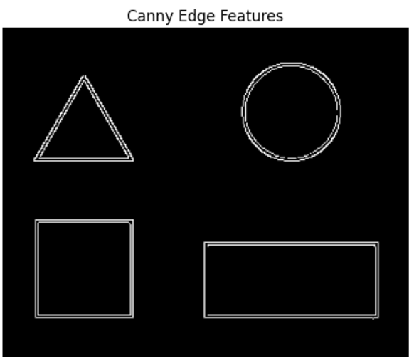

**Detecting Keypoint Descriptors (SIFT algorithm)**

**Scale-Invariant Feature Transform (SIFT)**

import cv2

import matplotlib.pyplot as plt

img = cv2.imread(r"D:\2023 Birla MSc-Bsc\MSc\MSc IT - IP\Practs\4shapes.png")

gray = cv2.cvtColor(img, cv2.COLOR_BGR2GRAY)

# Create SIFT object and detect keypoints

sift = cv2.SIFT_create()

keypoints, descriptors = sift.detectAndCompute(gray, None)

print(descriptors)

# Draw keypoints

img_kp = cv2.drawKeypoints(img, keypoints, None)

plt.imshow(cv2.cvtColor(img_kp, cv2.COLOR_BGR2RGB))

plt.title('SIFT Keypoints')

plt.axis('off')

plt.show()

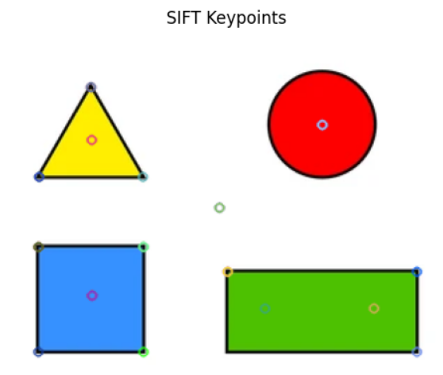

**Pract7:- Illustration of Image Forgery**

**Create a Python code for demonstrating any image forgery method e.g. Copy-Move method.**

import cv2

import numpy as np

import matplotlib.pyplot as plt

# Load image

image = cv2.imread(r"D:\2023 Birla MSc-Bsc\MSc\MSc IT - IP\Practs\sunandmoon.png")

image_rgb = cv2.cvtColor(image, cv2.COLOR_BGR2RGB)

# Simulate forgery: Copy a region and paste it elsewhere

forged = image_rgb.copy()

# Define region to copy (e.g., a 50x50 square)

x1, y1, w, h = 328, 358, 40, 40

region = forged[y1:y1+h, x1:x1+w]

# Define where to paste the copied region

x2, y2 = 200, 358

forged[y2:y2+h, x2:x2+w] = region

x3, y3 = 456, 358

forged[y3:y3+h, x3:x3+w] = region

# Display original and forged images

plt.figure(figsize=(10, 5))

plt.subplot(1, 2, 1)

plt.imshow(image_rgb)

plt.title("Original Image")

plt.axis("off")

plt.subplot(1, 2, 2)

plt.imshow(forged)

plt.title("Forged Image (Copy-Move)-Image from Outer Space Planet")

plt.axis("off")

plt.tight_layout()

plt.show()

cv2.imwrite(r"D:\2023 Birla MSc-Bsc\MSc\MSc IT - IP\Practs\sunandmoon_forged.png",forged)

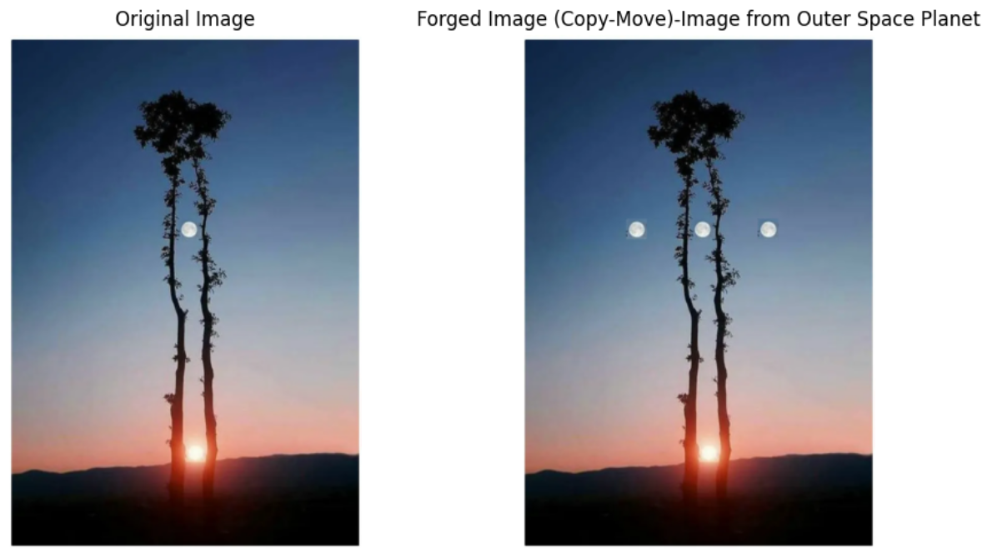

**Pract8:- Illustration of Image Forgery Detection Method.**

**Create a python code to detect if any forgery is made in an image.**

import cv2

import numpy as np

import matplotlib.pyplot as plt

def embed_watermark(image, watermark_text):

# Convert image to grayscale

gray = cv2.cvtColor(image, cv2.COLOR_BGR2GRAY)

gray = np.float32(gray)

# Apply DCT

dct = cv2.dct(gray)

# Embed watermark text as ASCII into DCT coefficients

watermark = [ord(c) for c in watermark_text] #ord gives ASCII code for every character in watermark_text

for i, val in enumerate(watermark):

dct[0, i] += val % 10 # Embed only the last digit of the ASCII code into only in low-frequency band (top row)

# Apply inverse DCT

watermarked_img = cv2.idct(dct)

watermarked_img = np.uint8(np.clip(watermarked_img, 0, 255))

return watermarked_img

# Load original image

image = cv2.imread(r"D:\2023 Birla MSc-Bsc\MSc\MSc IT - IP\Practs\sunandmoon.png")

watermarked = embed_watermark(image, "AUTHENTIC")

""" Simulate forgery by tampering with image"""

tampered = watermarked.copy()

tampered[358:398, 328:368] = 255 # White patch (fake object)

# Show images

plt.figure(figsize=(12, 4))

plt.subplot(1, 3, 1)

plt.imshow(cv2.cvtColor(image, cv2.COLOR_BGR2RGB))

plt.title("Original Image")

plt.axis("off")

plt.subplot(1, 3, 2)

plt.imshow(watermarked, cmap='gray')

plt.title("Watermarked Image")

plt.axis("off")

plt.subplot(1, 3, 3)

plt.imshow(tampered, cmap='gray')

plt.title("Tampered Image")

plt.axis("off")

plt.tight_layout()

plt.show()

"""

#Checking Image for Forgery

"""

def extract_watermark(image, length):

# Convert to grayscale and DCT

gray = np.float32(image)

dct = cv2.dct(gray)

# Extract the embedded values

extracted = ""

for i in range(length):

char_val = int(dct[0, i]) % 10

extracted += str(char_val)

return extracted

# Try to extract watermark from both images

wm_extracted_clean = extract_watermark(watermarked, len("AUTHENTIC"))

wm_extracted_tampered = extract_watermark(tampered, len("AUTHENTIC"))

print("Extracted from watermarked image:", wm_extracted_clean)

print("Extracted from tampered image:", wm_extracted_tampered)

if wm_extracted_clean != wm_extracted_tampered:

print("\n⚠️ Forgery Detected: Watermark integrity compromised.")

else:

print("\n✅ Image appears to be authentic.")

